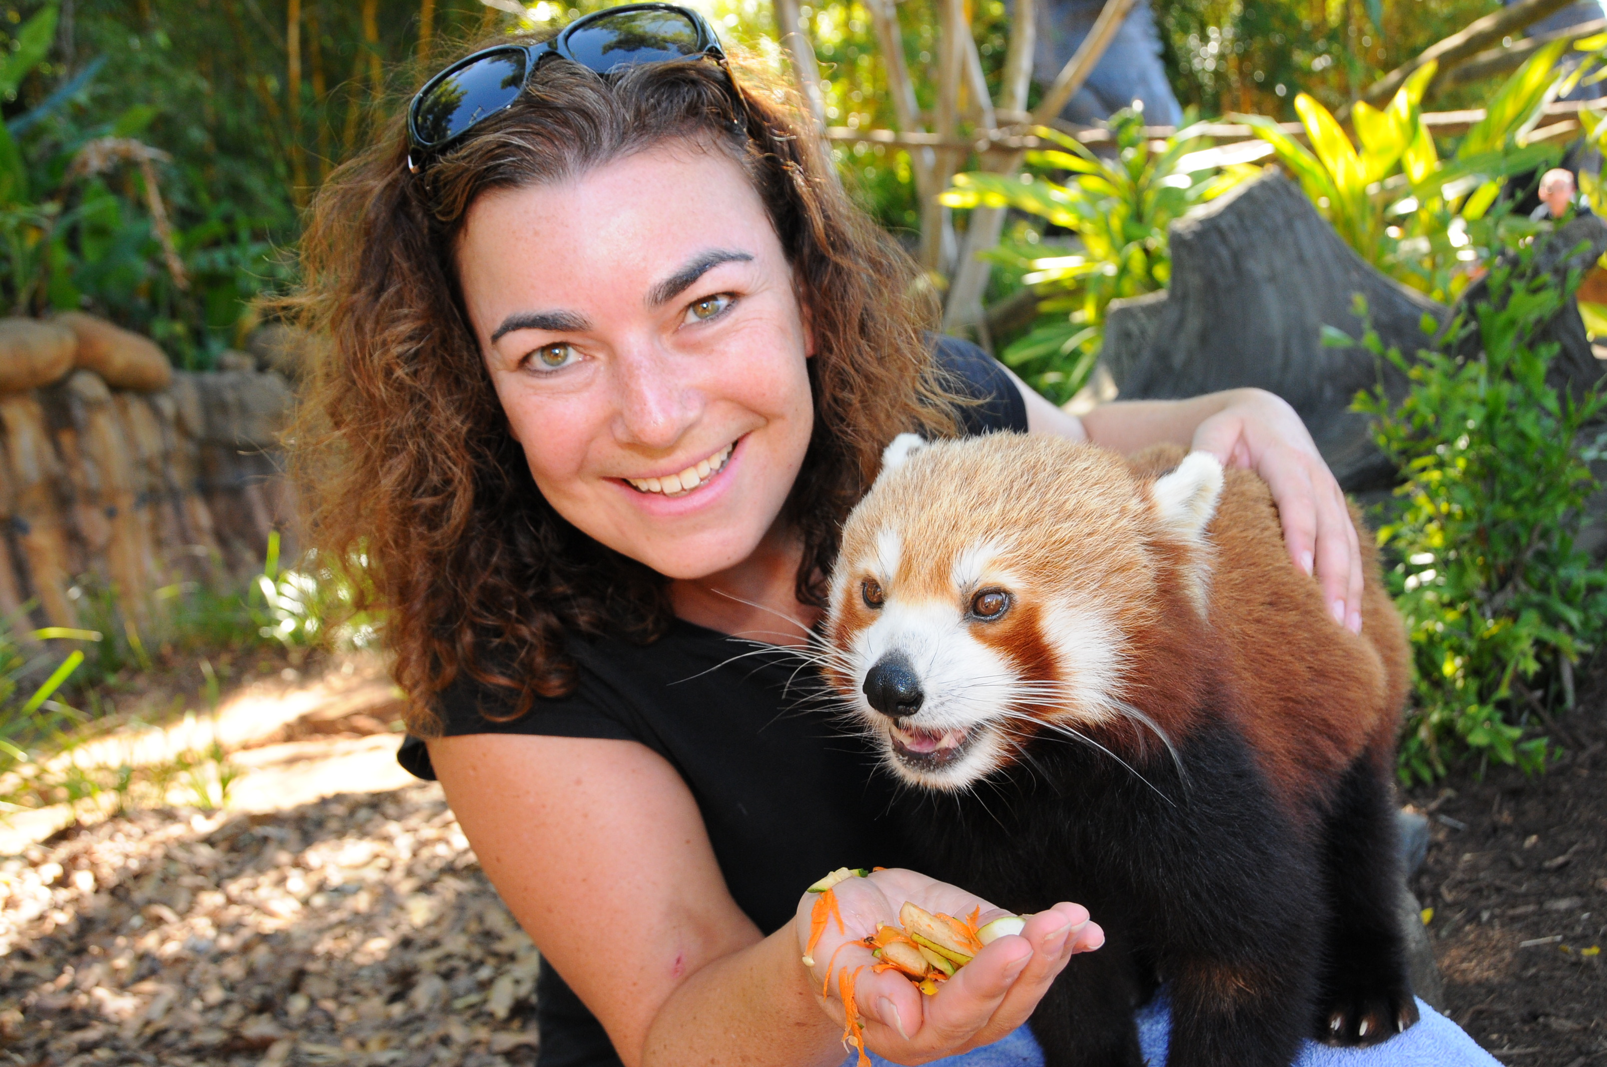 | Tourism 12 BL  Substantive Activity  Teacher: Alyssa Shore

Student Name Date
____________________ ________________

Substantive Activity (worth 5% of final course mark)

- Choose 2 provinces or territories. Answer the following in full sentences on a separate page for each.
  - Find 10 random facts about it – try to make them things that people haven’t heard before (ie White River, Ont. is the home of Winnie the Pooh).
  - What is one of their big tourist destinations?
  - What market segmentation would enjoy this the most? Give details from each category (geographic/psychographic/demographic)
  - Go to the tourism website of the province. How many people visited the province in the last year (you may need to go to the Destination Canada website to find this)?

Date Received Substantive Activity | Date Marked  By Teacher | Date of  Funding Claimed

