Tourism Careers In-Class Assignment

Go to the website https://www.go2hr.ca/careers-tourism.

PART A: Choose 3 different careers (each one from a different sector) and answer the following questions about them. You will find that some give strictly info about the career while others are the profiles of current employees in the job. Make sure that you choose at least one of each to answer the questions.

Career #1: ______________________________________________________

Sector: ______________________________________________________

Is it career info or a profile? If a profile, what is the name of the person who is discussed?

_________________________________________________________________________________________________

What are 3 responsibilities of this job?

1. _______________________________________________________________________________________________
2. _______________________________________________________________________________________________
3. _______________________________________________________________________________________________

What are some assets to have for knowledge/skills? List at least 3.

1. _______________________________________________________________________________________________
2. _______________________________________________________________________________________________
3. _______________________________________________________________________________________________

Are there potential future career paths with this job? List at least 2.

1. _______________________________________________________________________________________________
2. ________________________________________________________________________________________________

If this career is someone’s profile, quickly summarize some interesting things about the person or what he/she said about the job.

____________________________________________________________________________________________________________________________________________________________________________________________________________________________________________________________________________________________________________________________________________________________________________________________________________________________________.

Career #2: ______________________________________________________

Sector: ______________________________________________________

Is it career info or a profile? If a profile, what is the name of the person who is discussed?

_________________________________________________________________________________________________

What are 3 responsibilities of this job?

1. _______________________________________________________________________________________________
2. _______________________________________________________________________________________________
3. _______________________________________________________________________________________________

What are some assets to have for knowledge/skills? List at least 3.

1. _______________________________________________________________________________________________
2. _______________________________________________________________________________________________
3. _______________________________________________________________________________________________

Are there potential future career paths with this job? List at least 2.

1. _______________________________________________________________________________________________
2. _______________________________________________________________________________________________

If this career is someone’s profile, quickly summarize some interesting things about the person or what he/she said about the job.

____________________________________________________________________________________________________________________________________________________________________________________________________________________________________________________________________________________________________________________________________________________________________________________________________________________________________.

Career #3: ______________________________________________________

Sector: ______________________________________________________

Is it career info or a profile? If a profile, what is the name of the person who is discussed?

_________________________________________________________________________________________________

What are 3 responsibilities of this job?

1. _______________________________________________________________________________________________
2. _______________________________________________________________________________________________
3. _______________________________________________________________________________________________

What are some assets to have for knowledge/skills? List at least 3.

1. _______________________________________________________________________________________________
2. _______________________________________________________________________________________________
3. _______________________________________________________________________________________________
Are there potential future career paths with this job? List at least 2.
1. _______________________________________________________________________________________________
2. _______________________________________________________________________________________________

If this career is someone’s profile, quickly summarize some interesting things about the person or what he/she said about the job.

____________________________________________________________________________________________________________________________________________________________________________________________________________________________________________________________________________________________________________________________________________________________________________________________________________________________________.

PART B:
Find 2 current job opportunities in Langley (or area that you live) that might interest you.

Job 1:
Company: _________________________________________ Job Title: _________________________________________

Full/Part-time? __________________________________ Pay? ______________________________________________
Job Description summary: ______________________________________________________________________________________________ _______________________________________________________________________________________________ _______________________________________________________________________________________________
Duties (list 5 main ones):

1. _______________________________________________________________________________________________
2. _______________________________________________________________________________________________
3. _______________________________________________________________________________________________
4. _______________________________________________________________________________________________
5. _______________________________________________________________________________________________

Job Requirements: (list 3)

1. _______________________________________________________________________________________________
2. _______________________________________________________________________________________________
3. _______________________________________________________________________________________________

Date job was posted: _______________________________________

Why would this job interest you?

__________________________________________________________________________________________________________________________________________________________________________________________________________________
________________________________________________________________________________________________________________________
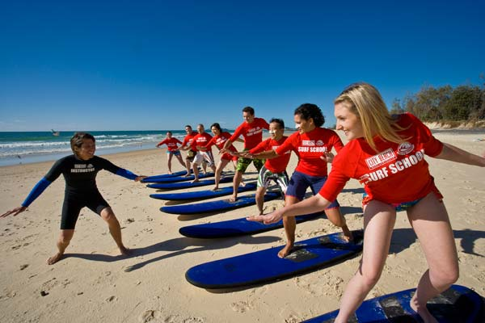
____________________________________________________________ ____________________________________________________________
________________________________________________________________________________________________________________________.

Job 2:
Company: _________________________________________ Job Title: _________________________________________

Full/Part-time? __________________________________ Pay? ______________________________________________
Job Description summary: ______________________________________________________________________________________________ _______________________________________________________________________________________________ _______________________________________________________________________________________________
Duties (list 5 main ones):

1. _______________________________________________________________________________________________
2. _______________________________________________________________________________________________
3. _______________________________________________________________________________________________
4. _______________________________________________________________________________________________
5. _______________________________________________________________________________________________

Job Requirements: (list 3)

1. _______________________________________________________________________________________________
2. _______________________________________________________________________________________________
3. _______________________________________________________________________________________________

Date job was posted: _______________________________________

Why would this job interest you?

_______________________________________________________________________________________________
_______________________________________________________________________________________________


 


