Map of BC Regions

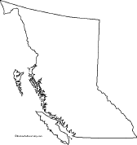
- Produce a map of BC that includes the following:
  - the 6 tourism regions
the following cities: Vancouver, Victoria, Whistler, Tofino, Kelowna, Nelson, Osoyoos, Williams Lake, Prince George, Fort St. John, Bella Coola, Cranbrook

