BC Geography Assignment – due Dec. 7 /20

- Select two of the six BC tourism regions.

  - My regions: _________________________________________________
_________________________________________________

PART 1 – Due June 15
Find the important information about both regions. This includes:
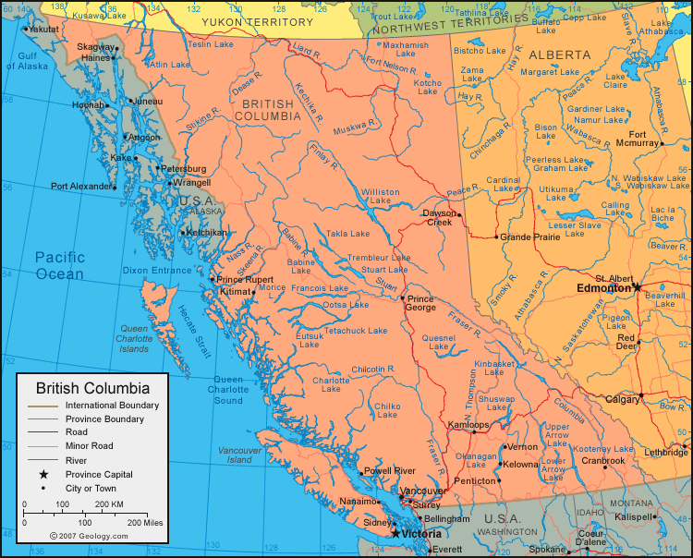
  - Population
  - Climate
  - Schools (post-secondary)
  - Popular tourist attractions
  - Events
  - Outdoor/Adventure Tourism
  - Tours offered
  - Popular types of accommodation/food and beverage for the target market
  - National/provincial parks in the area
  - Anything else you might find relevant

Write out this information in full sentences.

